|  |  |
| --- | --- |
| *Pacific Gas and Electric Company* | |
| Release 9.3 Installation Guide | |
|  |  |
|  |  |
| Project | ED AM/GIS |
|  |  |
| Prepared by | Subhankar Baidya |
| Date | 1/13/2015 |
| Version | 1.0 |
| Version Type | Final |

|  |  |  |  |
| --- | --- | --- | --- |
| Revision History | | | |
| Document # | Date | Author | Summary of Changes |
| 1.0 |  | Subhankar Baidya | Initial Document Creation |
|  |  |  |  |

# Introduction

## Purpose

This document is intended to detail the implementation and configuration steps required to implement Release 9.3 Installation Guide. This document describes the various configuration aspects required to complete any manual or automatic patch associated with this release. Each section in this document contains the steps required to patch the system in production.

## Terms Used

|  |  |
| --- | --- |
| OOTB | Out of the box. Unmodified from the commercial version. |
| TFS | Team Foundation Server |

## External Documents

Referenced are any external configuration documents or exports. These are documents that contain more detailed information about configuring a system or documents that can be loaded into an application to perform the configuration detailed in this document.

## List Of Fixes

Below is the list of change requests detailing all fixes for the data model for this release:

|  |  |
| --- | --- |
| **Item Number** | **Title** |
| [18578](http://edappgistfsprd1:8080/tfs/web/wi.aspx?pcguid=15e9a9d1-95cb-4dd0-abfe-5af14ae6201f&id=17684) | Master TFS Data Model 9.3 |
| 16522 | Create additional Subtypes on OpenPoint feature class |
| 18550 | PAR 76192: Operating Numbers on Secondary Busbars in SFO |
| 18304 | PAR 80065 add a new value to the “Pole Height” Domain |
|  |  |
|  |  |
|  |  |
|  |  |
|  |  |
|  |  |
|  |  |
|  |  |
|  |  |
|  |  |

## Summary of Steps to Complete Install

Contents

1 Introduction 3

1.1 Purpose 3

1.2 Terms Used 3

1.3 External Documents 3

1.4 List Of Fixes 4

1.5 Summary of Steps to Complete Install 5

2 Open a Database Connection in ArcCatalog 7

3 16522 - Create additional Subtypes on OpenPoint feature class 8

4 18550 - PAR 76192: Operating Numbers on Secondary Busbars in SFO 9

5 18304 - PAR 80065 add a new value to the “Pole Height” Domain 11

6 Add LABELTEXT3 field in ConduitSystem feature class 12

7 PGE_DCCONDUCTOR and PGE_DEACTIVATEDELECTRICLINESEGMENT class model names 15

7.1 Ensure the following class model names exist in the PGE ED Object Class Model Name domain; PGE_DCCONDUCTOR, PGE_DEACTIVATEDELECTRICLINESEGMENT 15

7.2 Ensure that the following featureClasses have their respective model name assigned 15

8 Create “ConduitNoRel” annotation class in ConduitSystemAnno 18

8.1 For EDGIS.ConduitSystemAnno 18

8.2 For EDGIS.ConduitSystem50Anno 21

9 Create new annotation class 24

9.1 For EDGIS.PriUGConductor50Anno 24

9.2 For EDGIS.SecUGConductor50Anno 25

10 18616 - Expand LANID in Production 26

11 Annotation expression for SwitchAnno:Default annotation class 27

12 14213 - PhotoVoltaicCell configuration 29

13 Data Model Version Table 32

14 Known Issues 33

# Open a Database Connection in ArcCatalog

1. Open ArcCatalog.
2. Within the Catalog Tree, expand “Database Connections” and open the active connection for this process. This is the connection that is referenced in the change request associated with this document (EDGIS<DB name in the format X#Y> )

# 16522 - Create additional Subtypes on OpenPoint feature class

1. Open up ArcCatalog
2. Connect as user: EDGIS
3. In the Electric Dataset, locate the “EDGIS.OpenPoint” feature class. Right click and select “Properties…”
4. In “Fields” tab, scroll to the bottom and add the following field.

Name: SECONDARYIDC

Alias: Secondary Indicator

Data Type: Text

Allow NULL: Yes

Domain: Yes No Indicator

Length: 5

1. Click Apply. Click OK to accept.

# 18550 - PAR 76192: Operating Numbers on Secondary Busbars in SFO

1. Open up ArcCatalog
2. Connect as user: EDGIS
3. In the Electric Dataset, locate the “EDGIS.DistBusBar” feature class. Right click and select “Properties…”
4. In “Fields” tab, scroll to the bottom and add the following field.

Name: OPERATINGNUMBER

Data Type: Text

Alias: Operating Number

Allow Nulls: Yes

Length: 15

1. Click Apply. Click OK to accept.
2. Right-click on the “EDGIS.DistBusBar” feature class and select “ArcFM Properties Manager”.
3. On the Field Info tab, select “Pri Dist Bus Bar” at the “Subtype” dropdown.
4. Select OPERATINGNUMBER field.
5. Set “Visible” property as “No”.
6. Click Apply. Click OK to accept.

**Create 50 scale Anno**

1. Connect as user: EDGIS
2. In the ArcCatalog tree view, right-click the **EDGIS.ElectricDataset** dataset.
3. Point to “**New**” and click “**Feature Class**”.
4. Type the name as “**DistBusBar50Anno**”.
5. Click the drop-down arrow and choose “ArcFM Annotation Feature” for the type of feature class.
6. Check the check box :

* “Link the annotation to the following feature class”.

1. Click the drop-down arrow and select “EDGIS.DistBusBar” feature class.
2. Click Next.
3. Enter reference scale as **1:600**. Map Unit as “Feet”. Check the below checkboxes:

* Create annotation when new features are added
* Update annotation feature’s shape is modified

1. Click Next.
2. Set “Label Field” as OPERATINGNUMBER.
3. Set Font name as “Arial”, Size = 6, Color as “Black”. Click “Bold”.
4. Click on “Symbol” button. Click on “Edit Symbol”. Set Vertical Alignment as “Center” and Horizontal Alignment as “Left”.
5. Click OK.
6. Click OK.
7. Click on “SQL Query” button. Write “OPERATINGNUMBER IS NOT NULL”. Click Ok.
8. Click on “Position” Button. Select “Offset Straight”. Click OK.
9. Set “**Offset**” = 2.5 points
10. Click Next.
11. Click Next.
12. Click Finish.
13. Find and right-click on the newly generated annotation relationship class and rename to “EDGIS.DistBusBar50AnnoRel”.

# 18304 - PAR 80065 add a new value to the “Pole Height” Domain

1. Open up ArcCatalog
2. Connect as user: EDGIS
3. Right click the database and select Properties.
4. In the Domains tab, scroll to the “Pole Height” domain.
5. Add new Height value 200 to the Pole Height domain

Domain: Pole Height

Code: 200

Description: 200

1. Click “Apply”. Click “OK” to accept the changes.

# Add LABELTEXT3 field in ConduitSystem feature class

1. Open up ArcCatalog
2. Connect as user: EDGIS
3. In the Electric Dataset, locate the “EDGIS.ConduitSystem” feature class. Right click and select “Properties…”
4. In “Fields” tab, scroll to the bottom and add the following field.

Name: LABELTEXT3

Data Type: Text

Alias: Label Text 3

Allow Nulls: Yes

Length: 100

1. Click Apply. Click OK to accept.
2. Right click on EDGIS.ConduitSystem. Select “ArcFM Properties Manager”
3. Go to “Field Model Names” tab
4. Select LABELTEXT3 field. Select “PGE ED Field Model Name” from the Model Name Domain dropdown.
5. Select LABELTEXT3 model name.
6. Click Apply. See the screenshot as given below:

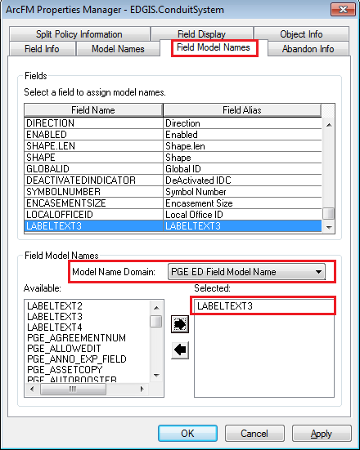

1. Go to “Field Info” tab. Select LABELTEXT3 field.
2. Assign properties as given in the below screenshot.

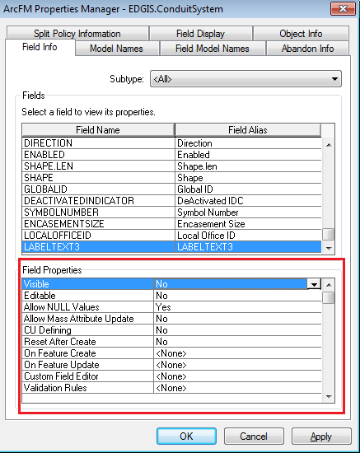

# PGE_DCCONDUCTOR and PGE_DEACTIVATEDELECTRICLINESEGMENT class model names

## Ensure the following class model names exist in the PGE ED Object Class Model Name domain; PGE_DCCONDUCTOR, PGE_DEACTIVATEDELECTRICLINESEGMENT

1. Right click on the database connection and select properties
2. Select the Domains tab
3. Select the item in the Domain Name column that says ‘PGE ED Object Class Model Name’
4. Ensure PGE_DCCONDUCTOR, PGE_DEACTIVATEDELECTRICLINESEGMENT exist in the code/value list.
5. **If Not**, add the model names as given below

* PGE_DCCONDUCTOR
* PGE_DEACTIVATEDELECTRICLINESEGMENT

## Ensure that the following featureClasses have their respective model name assigned

- EDGIS.DCConductor: PGE_DCCONDUCTOR

- EDGIS.DeactivatedElectricLineSegment: PGE_DEACTIVATEDELECTRICLINESEGMENT

1. Navigate to EDGIS. DCConductor. Right click on it. Select “ArcFM Properties Manager”
2. Go to “Model Names” tab
3. Select “PGE ED Object Class Model Name” from the Model Name Domain dropdown.
4. Ensure PGE_DCCONDUCTOR model name is selected. **If Not,** Select PGE_DCCONDUCTOR model name.
5. Click Apply. Click OK. See the screenshot as given below:

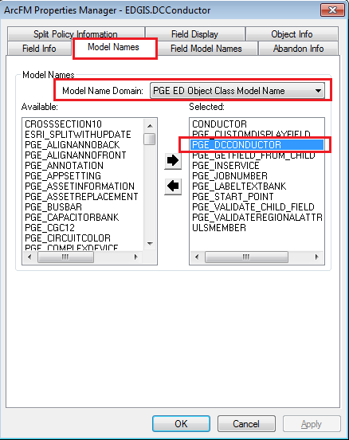

1. Navigate to EDGIS.DeactivatedElectricLineSegment. Right click on it. Select “ArcFM Properties Manager”
2. Go to “Model Names” tab
3. Select “PGE ED Object Class Model Name” from the Model Name Domain dropdown.
4. Ensure PGE_DEACTIVATEDELECTRICLINESEGMENT model name is selected. **If Not,** Select PGE_DEACTIVATEDELECTRICLINESEGMENT model name.
5. Click Apply. Click OK. See the screenshot as given below:

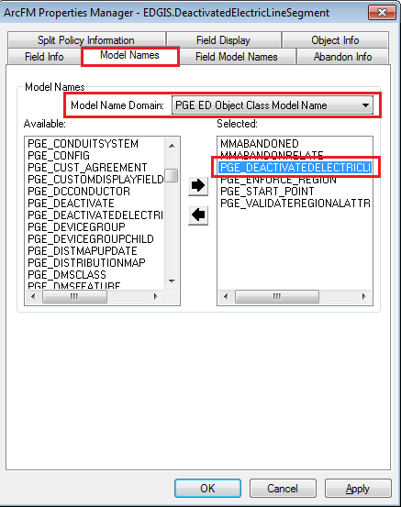

# Create “ConduitNoRel” annotation class in ConduitSystemAnno

## For EDGIS.ConduitSystemAnno

1. Connect to database thourgh ArcCatalog
2. Open EDGIS.ElectricDataset
3. Navigate to EDGIS.ConduitSystemAnno. Right Click on it. Select “Properties…”
4. Go to “Annotatio Classes”. Click on “New…” Button.
5. Name: **ConduitNoRel**
6. Assign properties as given in the below screen shot.

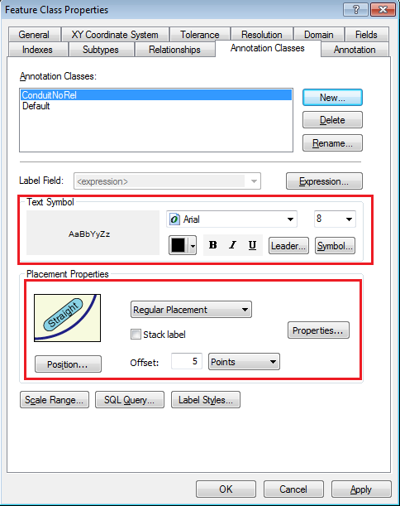

1. Click the “Expression…” buton. Delete the existing script. Copy the below script and paste it in the expression text area.

Function FindLabel ( [LABELTEXT3], [LABELTEXT2] )

if len([LABELTEXT3]) > 0 then

if len([LABELTEXT2]) > 0 then

FindLabel = [LABELTEXT3] + " & " + [LABELTEXT2]

else

FindLabel = [LABELTEXT3]

end if

FindLabel = trim(FindLabel)

end if

End Function

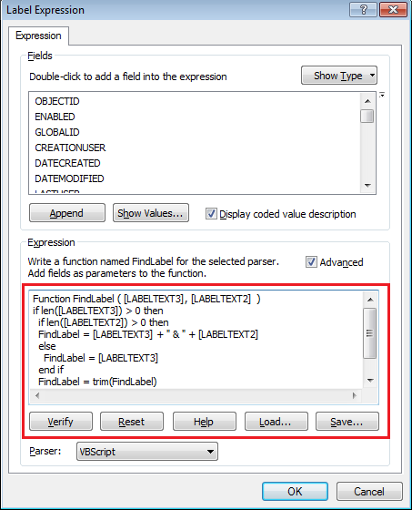

1. Click OK. Click Apply.
2. Select Default annotation class.

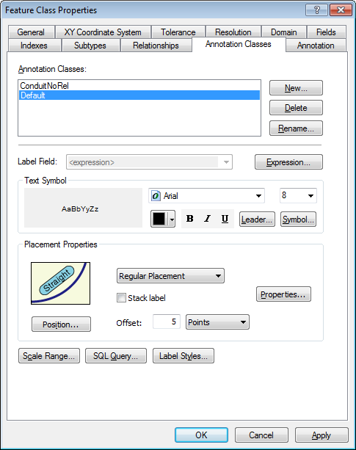

1. Click the “Expression…” buton. Delete the existing script. Copy the below script and paste it in the expression text area.

Function FindLabel ( [LABELTEXT], [LABELTEXT2] )

if len([LABELTEXT]) > 0 then

if len([LABELTEXT2]) > 0 then

FindLabel = [LABELTEXT] + " & " + [LABELTEXT2]

else

FindLabel = [LABELTEXT]

end if

FindLabel = trim(FindLabel)

end if

End Function

1. Click OK. Click Apply. Click OK

## For EDGIS.ConduitSystem50Anno

1. Connect to database thourgh ArcCatalog
2. Open EDGIS.ElectricDataset
3. Navigate to EDGIS.ConduitSystem50Anno. Right Click on it. Select “Properties…”
4. Go to “Annotatio Classes”. Click on “New…” Button.
5. Name: **ConduitNoRel**
6. Assign properties as given in the below screen shot

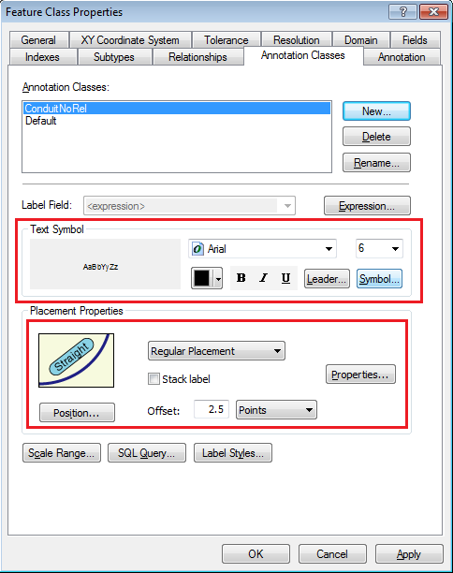

1. Click the “Expression…” buton. Delete the existing script. Copy the below script and paste it in the expression text area.

Function FindLabel ( [LABELTEXT3], [LABELTEXT2] )

if len([LABELTEXT3]) > 0 then

if len([LABELTEXT2]) > 0 then

FindLabel = [LABELTEXT3] + " & " + [LABELTEXT2]

else

FindLabel = [LABELTEXT3]

end if

FindLabel = trim(FindLabel)

end if

End Function



1. Click OK. Click Apply.
2. Select Default annotation class.

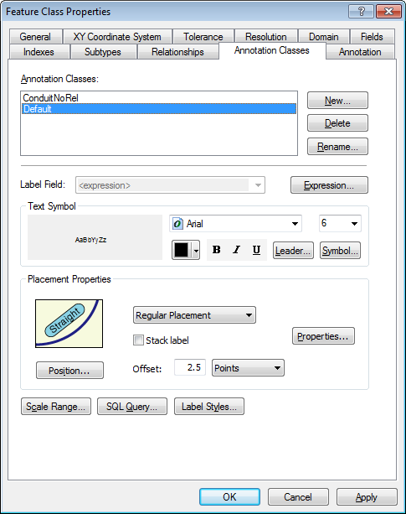

1. Click the “Expression…” buton. Delete the existing script. Copy the below script and paste it in the expression text area.

Function FindLabel ( [LABELTEXT], [LABELTEXT2] )

if len([LABELTEXT]) > 0 then

if len([LABELTEXT2]) > 0 then

FindLabel = [LABELTEXT] + " & " + [LABELTEXT2]

else

FindLabel = [LABELTEXT]

end if

FindLabel = trim(FindLabel)

end if

End Function

1. Click OK. Click Apply. Click OK

# Create new annotation class

## For EDGIS.PriUGConductor50Anno

1. Connect to database thourgh ArcCatalog
2. Open EDGIS.ElectricDataset
3. Navigate to EDGIS.PriUGConductor50Anno. Right Click on it. Select “Properties…”
4. Go to “Annotatio Classes”. Click on “New…” Button.
5. Name: **PriUGConduit**
6. Assign properties as given in the below screen shot.

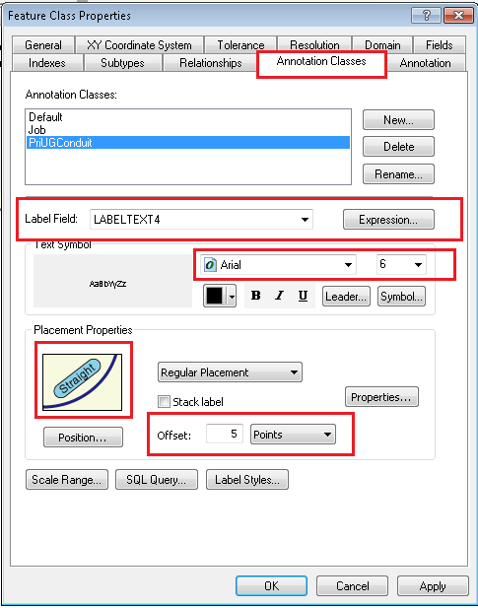

## For EDGIS.SecUGConductor50Anno

1. Connect to database thourgh ArcCatalog
2. Open EDGIS.ElectricDataset
3. Navigate to EDGIS.SecUGConductor50Anno. Right Click on it. Select “Properties…”
4. Go to “Annotatio Classes”. Click on “New…” Button.
5. Name: **SecUGConduit**
6. Assign properties as given in the below screen shot

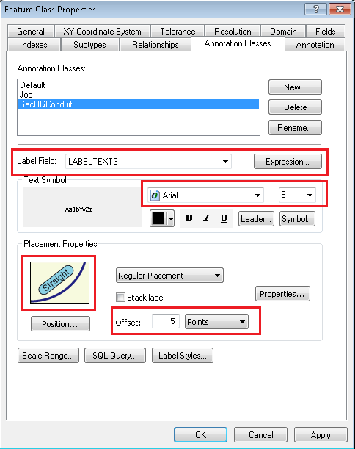

# 18616 - Expand LANID in Production

Model Edits for Change Detection 10.03.36

EDER Changes

1) Copy the folder "\\sfetgis-nas01\sfgispoc_data\ApplicationDevelopment\IBM_Delivery\Releases\PGEChangeDetection\10.03.36\ExpandSchematicsLanIDColumns" locally

2) Open the file PGE_EDERPostedSession\00_Set_Env_Vars.bat in a text editor

3) Modify the following variables to your environment (EDER Maintenance database instance)

* PATH_TO_SDE
* DB_INSTANCE
* EDGIS_PWD

4) Save the file

5) Ensure you have exclusive access to the EDER Maintenance database instance

6) In a command prompt, go into the folder (e.g. PGE_EDERPostedSession) and run the following file, ensuring you press keys when prompted:

0_Change_Field_With_Data.bat

7) Ensure there were no errors in the output

# Annotation expression for SwitchAnno:Default annotation class

1. Connect to database thourgh ArcCatalog
2. Open EDGIS.ElectricDataset
3. Navigate to EDGIS.SwitchAnno. Right Click on it. Select “Properties…”
4. Go to “**Annotatio Classes**”. Select **Default** annotation class. Click on “**Expression…**” button.

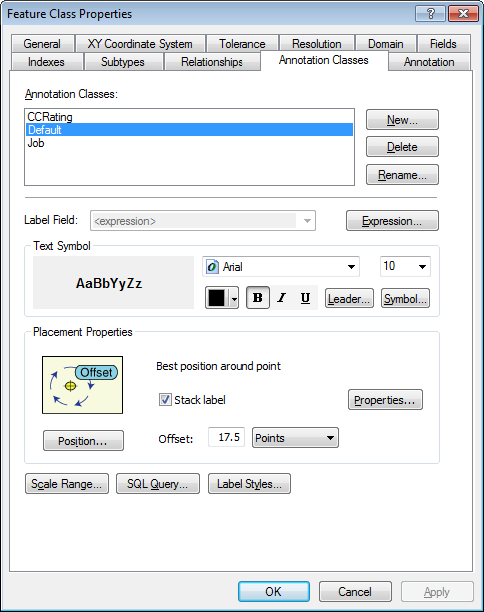

1. Delete the existing script. Copy the below script and paste it in the expression text area.

Function FindLabel ( [SubtypeCD], [OperatingNumber], [Class]  ,[ComplexDeviceIdc]  )

suffix = ""

if [SubtypeCD] = "Subsurface Switch" Or [SubtypeCD] = "Overhead Switch" Or [SubtypeCD] = "Padmount Switch" Then

  If [Class] = "II" Then

    suffix = "- II"

  End If

End If

if [SubtypeCD] = "Overhead Disconnect" and [ComplexDeviceIdc] = "No" Then

  FindLabel = [OperatingNumber] + chr(129) + vbCrLf + "SB" + vbCrLf +  chr(129)

else

  FindLabel = [OperatingNumber] + suffix + vbCrLf + chr(129)

End if

End Function

1. Click OK, Click Apply. Click OK.

# 14213 - PhotoVoltaicCell configuration

1. Gain exclusive access to the environment
2. Open ArcCatlog
3. Connect to EDGIS database as EDGIS user
4. Navigate to ‘EDGIS. PhotoVoltaicCell Feature Class

**Convert PhotoVoltaicCell feature to ArcFM feature.**

a.   Right click the feature class, select ArcFM Solution Object Converter.

b.   Select Convert to use ArcFM Objects and click OK.

c.   If “No tables were converted” pops up at the end, this means it is already an ArcFM object. You can safely move on to the next step.

d. Click Apply then Click Ok.

**Assign "ArcFM Login User Name" AU to LASTUSER field at "On Feature Update" property at Field Info tab  of ArcFM Properties Manager.**

a. Right click the feature class and select ArcFM Properties Manager.

b. Select the Field Info tab

c. Locate the LASTUSER field

d. Select the dropdown next to On Feature Update and select ArcFM Login User Name

e. Click Apply then Click Ok.

**Assign "ArcFM Login User Name" AU to CREATIONUSER field at "On Feature Create" property at Field Info tab  of ArcFM Properties Manager.**

a. Right click the feature class and select ArcFM Properties Manager.

b. Select the Field Info tab

c. Locate the CREATIONUSER field

d. Select the dropdown next to On Feature Create and select ArcFM Login User Name

e. Click Apply then Click Ok.

**Assign "ArcFM Current Date" AU to DATECREATED field at "On Feature Create" property at Field Info tab  of ArcFM Properties Manager.**

a. Right click the feature class and select ArcFM Properties Manager.

b. Select the Field Info tab

c. Locate the DATECREATED field

d. Select the dropdown next to On Feature Create and select ArcFM Current Date

e. Click Apply then Click Ok.

**Assign Division Namedomain  to Division field of PhotoVoltaicCell feature class.**

a. Double click the feature class and click the Fields tab.

b.  Locate the **Division** field, select it and assign the **Division Name** domain to the field by selecting it from the dropdown next to ‘Domain’.

c. Click Apply then Click Ok.

**Add "ArcFM Structure Relate" AU into "On Feature Create" at Object Infotab  of ArcFM Properties Manager.**

a. Right click the feature class and select ArcFM Properties Manager.

b. Select the Object Info tab

c. Select the dropdown next to On Feature Create and select Multiple

d. Assign ArcFM Structure Relate from the left hand side

e. Click Apply then Click Ok.

**Assign "ArcFM Manual Angle Setter" to "Create Edit Task" at Object Infotab  of ArcFM Properties Manager.**

a. Right click the feature class and select ArcFM Properties Manager.

b. Select the Object Info tab

c.  Select the dropdown next to Create Edit Task and select ArcFM Manual Angle Setter

d. Click Apply then Click Ok.

**Add "PGE Populate Local Office AU" auto updator into "On Feature Create"  and "On Feature Update" at Object Info tab  of ArcFM Properties Manager.**

a. Right click the feature class and select ArcFM Properties Manager.

b. Select the Object Info tab

c. Select the dropdown next to On Feature Update and select PGE Populate Local Office AU

d. Repeat step C for On Feature Create.

e. Click Apply then Click Ok.

**Assign "ArcFM Current Date" AU to DATEMODIFIED field at "On Feature Update" property at Field Info tab  of ArcFM Properties Manager.**

a. Right click the feature class and select ArcFM Properties Manager.

b. Select the Field Info tab

c. Locate the DATEMODIFIED field.

d. Select the dropdown next to On Feature Update and select ArcFM Current Date

e. Click Apply then Click Ok.

**Add "ArcFM Structure Relate" AU into "On Feature Update" at Object Infotab  of ArcFM Properties Manager.**

a. Right click the feature class and select ArcFM Properties Manager.

b. Select the Object Info tab

c. Select the dropdown next to On Feature Update and select ArcFM Structure Relate

d. Click Apply then Click Ok.

**Set "No" to Visible property at Field Info tab  of ArcFM Properties Manager.**

a.  Right click the feature class and select ArcFM Properties Manager.

b.  Select the Field Info tab

c.  Locate the SHAPE filed

d. Set the Visible property to ‘No’.

e. Click Apply then Click Ok.

# Assign AUs for UFM

COMMUNICATIONCONNECTOR

COMMUNICATIONSPLICE

CROSSSECTION10ANNO

DIMENSION

DUCT

DUCTANNOTATION

DUCTBANK

DUCTNOTEANNO

ELECTRICCONNECTOR

UFMFLOOR

UFMWALL

UGELECTRICSPLICE

1. For each of the above feature classes, do the following:
   1. Note: the above feature classes are found either in the UFMDataset or the ElectricDataset.
   2. Right click the feature class and select ArcFM Properties Manager.
   3. In the Object Info tab, select the On Feature Create dropdown and click <Multiple>.
   4. Assign the PGE Sync Facility IDs AU to it.
   5. Repeat for the next feature class.

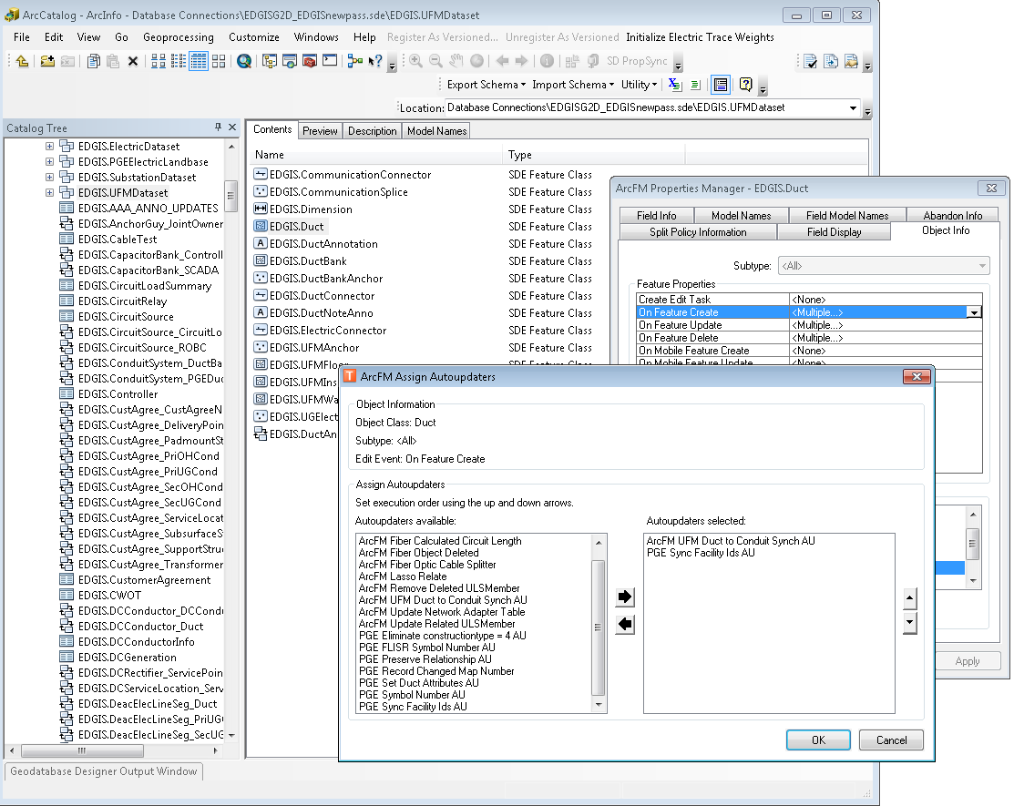

1. In the UFMDataset, right click the DuctAnno feature class and select ArcFM Properties Manager.
2. In the Object Info tab, select the dropdown next to On Feature Create and select <Multiple>.
3. Assign the PGE Preserve Anno Angle AU.  
   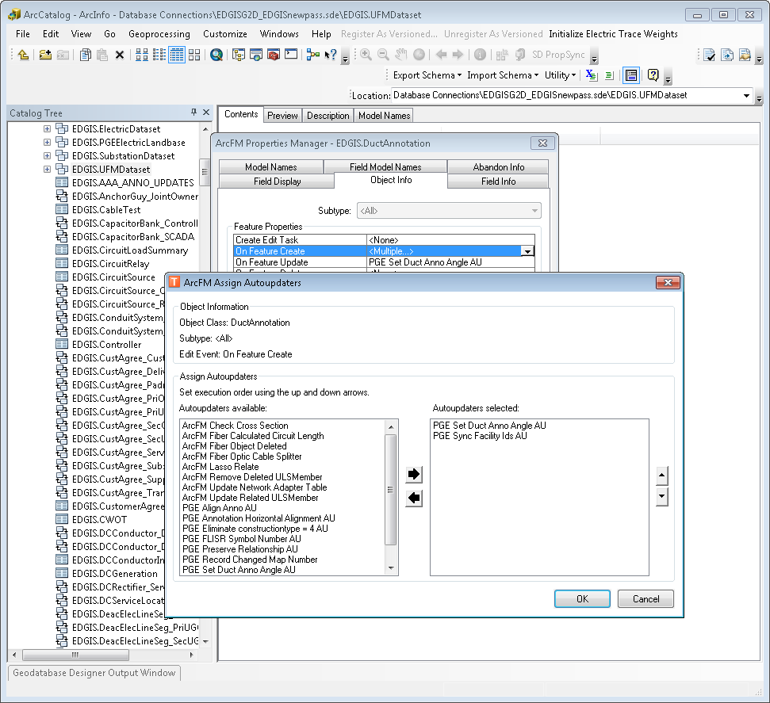
4. Repeat the above steps for On Feature Update on DuctAnno.

# Data Model Version Table

**Database Configuration:**

1. Open SQL Plus.
2. Log in using the same server and user as was used in section 2.  
     
   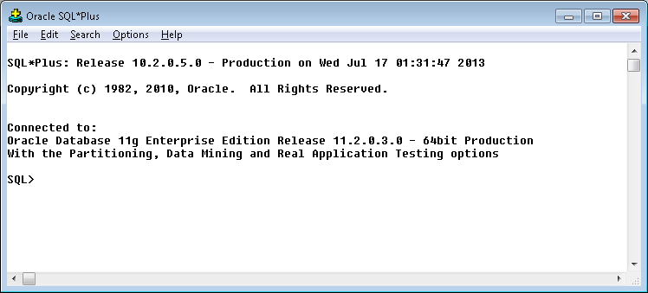
3. Run the SQL below:

update pgedatamodelversion set currentidc='N' where currentidc='Y';

insert into pgedatamodelversion (OBJECTID, CURRENTIDC, DATEAPPLIED, APPLIEDBYPERSONNAME, MODELVERSION) values (**INSERT NEXT VALID ID**,'Y',sysdate,'**<INSERT TEAM MEMBER DONE BY>**','**9.3** GOLD **CR18578**');

commit;

# Known Issues

<Please List any other issues encountered here while following the document>